Project Design Phase
Problem – Solution Fit Template

Date | 28 September 2026
Team ID | SWTID-2026-6232
Project Name | AI WeatherWise API
Maximum Marks | 2 Marks

Problem – Solution Fit Template:
Users need a simple and convenient way to access weather information and understand what it means for their daily activities. Existing weather services may provide weather data, but users may still need separate guidance for recommendations, explanations, and weather-related questions.
Purpose:
❑ Solve weather-related problems by providing simple and understandable weather information to users.
❑ Improve user convenience by bringing weather information, AI summaries, recommendations, and chatbot assistance into a single system.
❑ Strengthen user interaction by providing clear AI-generated responses and useful weather-based guidance.
❑ Increase user satisfaction by addressing frequent weather-related needs such as clothing suggestions, outdoor activity guidance, and weather queries.
❑ Understand the existing challenges faced by users while accessing and interpreting weather information in order to improve their overall weather experience.

Template:
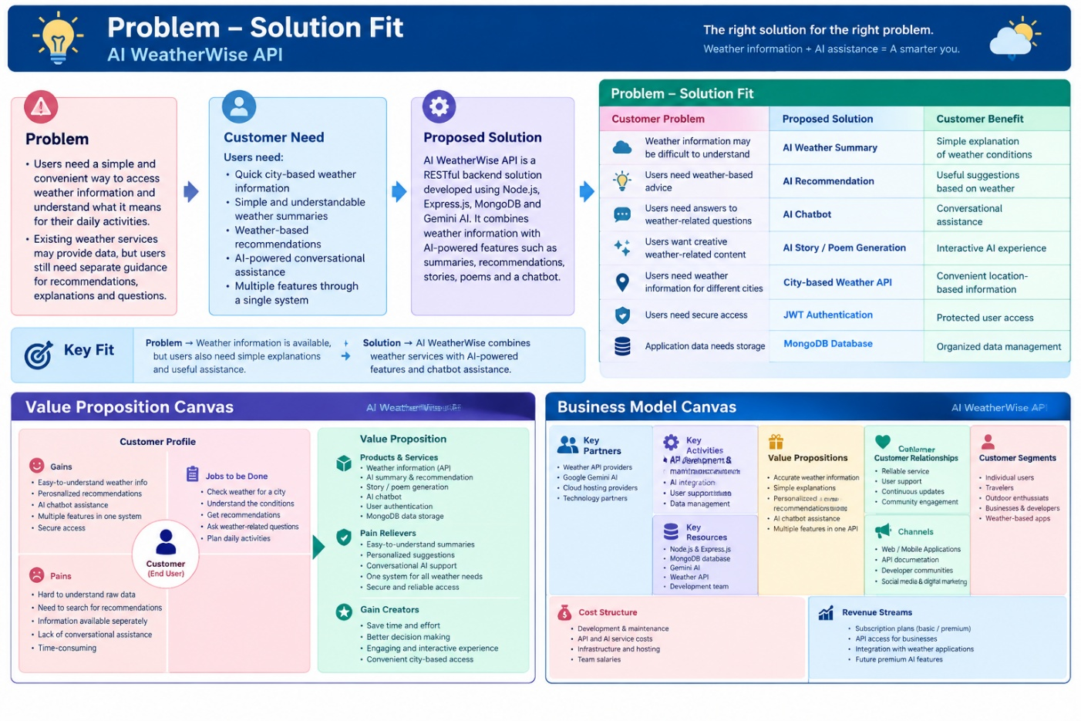
References:
- https://www.ideahackers.network/problem-solution-fit-canvas?utm_source=chatgpt.com
- https://www.ideahackers.network/blog/problem-solution-fit-canvas-explained?utm_source=chatgpt.com

